Digital Notebook Solution & Organizer
Anora, Cindy Marie L. | Deloria, Kevin Jude A. | Engbino, Jesrel | Villanueva, Aimie
University of San Jose-Recoletos | University of San Jose-Recoletos | University of San Jose-Recoletos | University of San Jose-Recoletos
P2 B10 L27 Deca Homes | 3A Rainbow Village | Upper Linao | 359 Upper Lipata
Tungkil, Minglanilla, Cebu | Kinasang-an, Pardo, Cebu City | Minglanilla, Cebu | Minglanilla, Cebu
+639323691461 | +639224424166 | +639233422155 | +639324183141
cinmaran@gmail.com | akiwarheit@gmail.com | jesrel042792@gmail.com | aim.knight17@gmail.com

ABSTRACT
Note-taking is important for both academic and professional life. Without the skill of note-taking, one may capture less information in a meeting, or not recall an important theory that your professor mentioned in a lecture. It is as ancient an art as any; there are hefty tomes on the subject of how to best capture and organize information in a swift and legible manner and courses devoted to the subject in colleges.
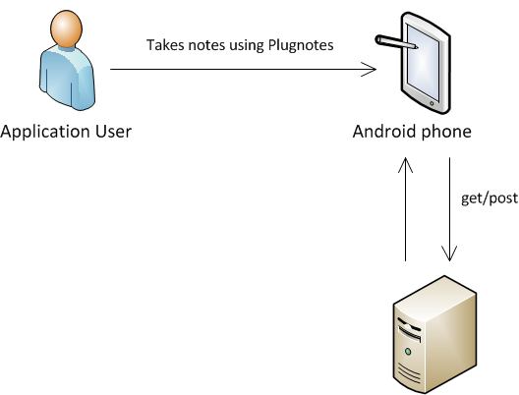
Our aim is to create an Android application that introduces an alternative and innovative solution to note taking. To create an application that lessens the hassles of the pen and paper paradigm. We do not want to replace the convention, but we want to innovate and explore on solutions brought to us by the digital age.
To achieve our goal, it is important to understand the art itself. It is important to study the essential components of effective note taking. To answer the questions; what makes the pen and paper very effective? How will we make note taking easier? These questions will be the foundation of our project, these will help us design and implement functionalities that users want and need.
To find out more about note-taking, its core components, and what features to implement, we will create personas. Personas are fictional characters created to represent the different user types within a targeted demographic, attitude and/or behavior set that might use a site, brand or product in a similar way. Personas will help us understand what it takes to become effective at note-taking.
Our project is divided into two major components; the web application and the Android application. The web application serves as the user’s interface to our application whenever he is accessing using a web browser. In the web app, the user will be able to do sharing and viewing of his notes. Sharing can be done through social networking apps such as Facebook and Google+. The Android application serves as the tool in note-taking, the user will be able to take notes using his mobile phone, utilizing technologies such as the camera and speech-to-text.

Keywords: note-taking, pen and paper, Android notebook application, mobile phone

INTRODUCTION

RELATED LITERATURE

DESIGN MODEL

Permission to make digital or hard copies of all or part of this work for personal or classroom use is granted without fee provided that copies are not made or distributed for profit or commercial advantage and that copies bear this notice and the full citation on the first page. To copy otherwise, or republish, to post on servers or to redistribute to lists, requires prior specific permission and/or a fee.
Conference’04, Month 1–2, 2004, City, State, Country.
Copyright 2004 ACM 1-58113-000-0/00/0004…$5.00.

TESTING
The testing procedure would be perform on five different scenarios. The application utilizes the Optical Character Recognition.

Scenario 1
In this scenario, the image to be read by the OCR has texts that can be extracted.

ACKNOWLEDGMENTS
Thank you, Internet. We acknowledge you. Keep it up! Good work! ☻

REFERENCES
- Cemer, Ron, sourceforge.net/projects/javaocr/
- stackoverflow.com

Columns on Last Page Should Be Made As Close As Possible to Equal Length

